MCC Writing Center 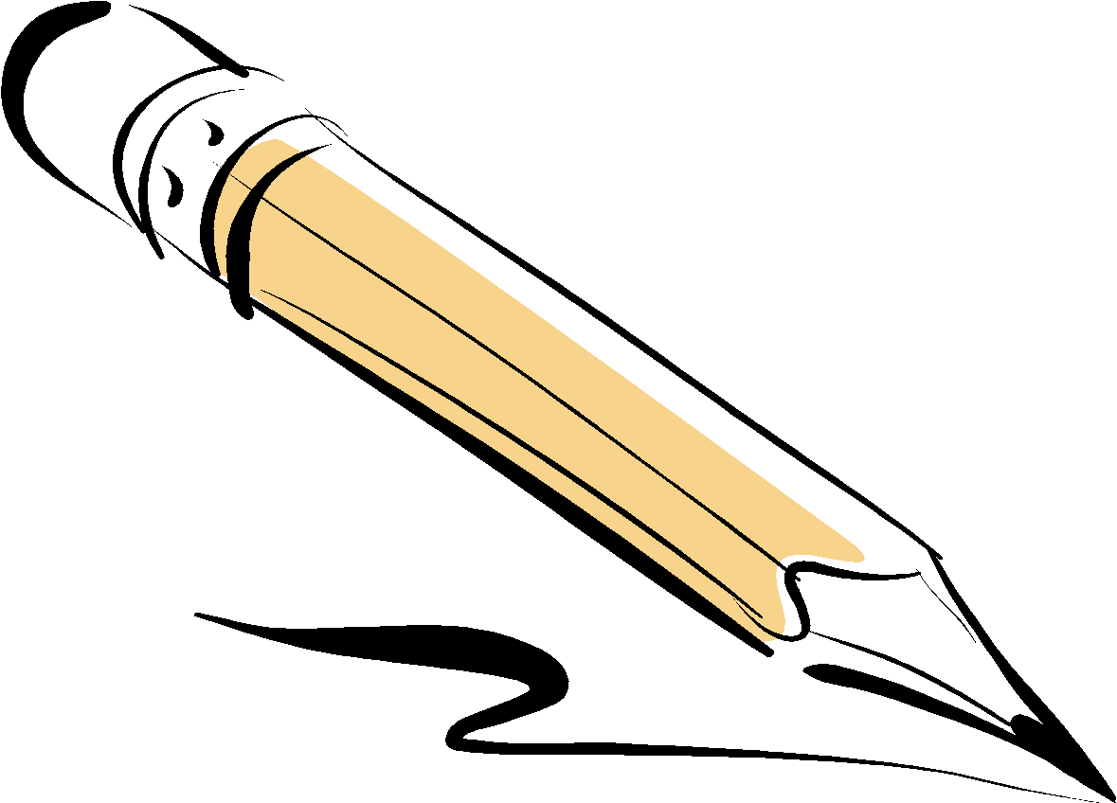
APA Style, 7th Edition
The American Psychological Association (APA) governs research and citations styles as well as paper formatting and publishing guidelines for papers written in scientific fields.
For a detailed list of changes, consult the Introduction chapter of the APA Publication Manual (7th ed.), which is available from the APA in PDF form here: https://apastyle.apa.org/products
/publication-manual-7th-edition-introduction.pdf?_ga=2.83240854.1022366773.1581433112-1633565752.1581433112
Useful Online Resources:
- Online Writing Guide (https://owl.purdue.edu/owl/research_and_citation/apa_style/apa_formatting_and_style_guide/general_format.html)
- Official APA Style Guide Webpage (www.apastyle.org)

Inclusive and bias-free language
Writing inclusively and without bias is the new standard, and APA’s new publication manual contains a separate chapter on this topic.
The guidelines provided by APA help authors reduce bias around topics such as gender, age, disability, racial and ethnic identity, and sexual orientation, as well as being sensitive to labels and describing individuals at the appropriate level of specificity.
Formatting
APA uses specific formatting for everything from the cover page and abstract to the header and references page. One of the best ways to learn the formatting is to look at a sample paper with annotations that point out the specific formatting guidelines.
Online Writing Lab Sample Paper: http://owl.english.purdue.edu/owl/resource/560/18/
Your basic guidelines include:
- 1” Margins on All Sides
- Cover Page (p. 1), Abstract (p. 2), Essay (p. 3+), References (Begin a New Page)
The running head on the title page now contains only a page number and the (shortened) paper title.
Use only one space after a period at the end of a sentence.

Use double quotation marks instead of italics to refer to linguistic examples: APA endorses the use of the singular pronoun “they.”
Font Options Have Changed
Font Options Include the Following;
Increased flexibility regarding fonts: options include Calibri 11, Arial 11, Lucida Sans Unicode 10, Times New Roman 12, and Georgia 11.
Just remember to use the same font throughout your paper.

Line Spacing
- In general, double-space all parts of an APA-style paper, including the abstract; text; block quotations; table and figure numbers, titles, and notes; and the reference list (including between and within entries).Do not add extra space before or after paragraphs.
- Exceptions to double-spacing are as follows:
  - Title page: Insert a double-spaced blank line between the title and the byline on the title page. Double space the rest of the title page.
  - Tables: The table body (cells) may be single-spaced, one-and-a-half-spaced, or double-spaced, depending on which is the most effective layout for the information. Double-space the table number, title, and notes.
Internal Citations
APA style requires that you cite all information you did not have before you began the research process, even if you reworded it. This means you need to cite a summary, paraphrase, or a quotation. The general rule is to over-cite. The format includes the author’s last name and the year of publication either in a signal phrase or in a parenthetical citation.
Signal Phrase Citation
According to Cutshall (2007), smaller schools statistically result in better retention for students.
Parenthetical Citation
Smaller schools statistically result in better retention for students (Cutshall, 2007).
Quotations
If you are using a direct quotation, APA also requires you to include the page number/s on which the quotation appears. If it’s an online resource you may need to provide paragraph numbers. Check with your instructor. Example: (Cutshall, 2007 para. 5)
Other Variations
Number of Authors | Signal Phrase | Parenthetical
One Author | Smith (2015) assert... | (Smith, 2015)
Two Authors | Smith and Jones (2015) assert... | (Smith & Jones, 2015)
3 or More Authors* | Forsythe et al. (1914)... | (Forsythe et al., 1914)
No Author | In “Article Title” (2020)... | (“First Few Words,” 2019)

*The in-text citation for works with three or more authors is now shortened right from the first citation. You only include the first author’s name and “et al.”.
(Taylor et al., 2018) instead of (Taylor, Kotler, Johnson, & Parker, 2018)
References Entries
Every source you use needs to include a references entry that will guide your reader back to your research. To Format Your References Page:
- Start on a New Page
- Alphabetize Your Entries (not the authors in the entry)
- Use a Hanging Indent
- Continue with Double Spacing
- Titles of Articles use Sentence Case: Only the first letter of the first word is capitalized
- Titles of Periodicals use Title Case: Capitalize All the Major Words
Changes for 7th Edition:
Surnames and initials for up to 20 authors (instead of 7) should be provided in the reference list.
Miller, T. C., Brown, M. J., Wilson, G. L., Evans, B. B., Kelly, R. S., Turner, S. T., Lewis, F., Lee, L. H., Cox, G., Harris, H. L., Martin, P., Gonzalez, W. L., Hughes, W., Carter, D., Campbell, C., Baker, A. B., Flores, T., Gray, W. E., Green, G., … Nelson, T. P. (2018).
URLs are no longer preceded by “Retrieved from,” unless a retrieval date is needed. The website name is included (unless it’s the same as the author), and web page titles are italicized.
Walker, A. (2019, November 14). Germany avoids recession but growth remains weak. BBC News. https://www.bbc.com/news/business-50419127
For ebooks, the format, platform, or device (e.g. Kindle) is no longer included in the reference, and the publisher is included.
Brück, M. (2009). Women in early British and Irish astronomy: Stars and satellites. Springer Nature. https:/doi.org/10.1007/978-90-481-2473-2
Authors:
Use the author’s last name followed by their initials.
If there is no author, you can use a corporation or organization as the author.
If there is still no author, move the title to the author’s spot, followed by the date.
DOIs are formatted the same as URLs. The label “DOI:” is no longer necessary.
https://doi.org/10.1080/02626667.2018.1560449
Books
Author, A. A., & Author, B. B. (Copyright Year). Title of the book (7th ed.). Publisher. DOI or URL

Edited Books
Author, A. A., & Author, B. B. (Copyright Year). Title of the book chapter. In A. A. Editor & B. B. Editor (Eds.), Title of the book (2nd ed., pp. #–#).Publisher. DOI or URL
Websites
Most articles found electronically require the URL. You only omit the URL if you have a physical copy of the official publication.
Author, F. M. & Author F. M. (Date of publication). Title of page [Format description when necessary]. https://www.someaddress.com/full/url/
American Nurses Association. (2019). Know your disaster [PDF]. http://nursingworld.org/MainMenuCategories/WorkplaceSafety
/Healthy-Work-Environment/DPR/KnowYourDisaster
All 33 Chile miners freed in flawless rescue. (2010, October 13). http://www
.msnbc.msn.com/id/39625809/ns/world_news-americas/
Periodicals
Author, A. A., & Author, B. B. (Year). Title of the article. Name of the Periodical, volume(issue), #–#. https://doi.org/xxxx
Anderson, A. K. (2005). Affective influences on the attentional dynamics supporting awareness. Journal of Experimental Psychology: General, 154, 258–281. https://doi.org/10.1037/0096-3445.134.2.258
Dejka, J. (2019, October 30). Nebraska ACT scores reveal college-readiness gap between ethnic, racial groups. Omaha World Herald, https://www.omaha.com/news/plus/nebraska-act-scores-reveal-college-readiness-gap-between-ethnic-racial/article_f26249ad-088f-5fb9-a45f-d2452271301d.html
EbscoHost
All of the Ebsco host databases offered through Metro have a link to the APA 6th edition citation. Click the title of the article (this will take you to the information page/Detailed Record)
- Click “Cite” from the right column of tools
- Highlight and copy the APA citation
- Use common sense to check for errors

Missing Information
Sometimes a source will be missing a piece of information such as the author, the date, or even the title. If important information is missing, question the credibility of the source. If you believe it is still worth using, the APA website will guide you on how to navigate these missing pieces of information: https://blog.apastyle.org/apastyle/2012/05/missing-pieces.html OR https://bit.ly/2PTa7bt
Capitalization
Guidelines from APA:
Do capitalize the Following: | Do NOT Capitalize the Following:
- Authors/Names of People | - Theories or philosophies
- All major words in titles of periodicals | - Therapies
- Brand NamesLegal Materials | - Concepts
- First word of a sentence | - Diseases
- First word after a colon (:) | - Condition or group in an experiment
https://blog.apastyle.org/apastyle/2012/02/do-i-capitalize-this-word.html OR https://bit.ly/32nmtuV
Annotated Bibliographies
The APA Publication Manual, 7th edition discusses annotated bibliographies, as they, “can also constitute one element of a research paper in fields that require bibliographies rather than reference lists” (APA 7th edition, 307). Chapter 2 provides guidelines for creating and properly ordering references in an annotated bibliography.
Headers and Headings
The running head rules are “simplified” and the words “Running head:” are no longer required for student or professional papers. The writer still needs to put their ABBREVIATED TITLE (in all caps) in the header, starting with the first page.
Each distinct section of an academic paper should start with a level one heading. The seventh edition changes only level three, four, and five headings. All headings are now written in title case (important words capitalized) and boldface.
APA Headings
Level | Format
1 | Centered, Boldface, Title Case Heading  Text starts a new paragraph.
2 | Flush left, Boldface, Title Case Heading  Text starts a new paragraph.
3 | Flush Left, Boldface Italic, Title Case Heading  Text starts a new paragraph.

Formatting Figures
When including a figure in an APA style paper, there are a number of things to consider. First, make sure your picture, map, graph, or other image is necessary. It should enhance you argument or information in a way that is important. Ask yourself what happens if you remove the image. If the paper becomes less clear or less persuasive because of it, then you have chosen well.
PICTURE, MAP, GRAPH, or OTHER IMAGE
To format your visual, insert it into your paper and select the appropriate tools to align it squarely with your text. Both the visual and its caption should fit within the 1” margins of your paper. The caption should sit in a text box directly below the image and should not have a border around it. The font should be consistent with the font used in your text, and it should be single spaced.
Figure 1. How to create figures in APA style. This figure illustrates effective elements in APA style figures (Citation, year).

After you label the figure, the caption should provide a clear explanation of what is important about the image. If your paper is proposing changes to the pick-up and drop off policies at an elementary school, you may include a map of the school and streets used for this purpose. Perhaps you could even annotate them to show the flow of traffic, crossing guards, and other key items you’d like to change. A caption that says, “Figure 1. Map of school parking lot,” isn’t useful. By contrast, a caption that says, “Figure 1. Map of proposed changes to school pickup and drop-off lanes” is more useful.
Finally, you need to reference the figure within your paper to integrate it into your ideas. You might say: Figure 1 illustrates the way to integrate figures in APA Style. This sentence reference should be near the figure integration, typically within half a page.
Ultimately, your image requires four pieces:
- Figure label: Figure 1
- Caption that provides a clear explanation
- Parenthetical citation if the image came from another source
- A reference to the image in a nearby sentence.

Nondiscrimination and Equal Opportunity Statement— Metropolitan Community College does not discriminate on the basis of race, color, national origin, religion, sex, marital status, age, disability or sexual orientation in admission or access to its programs and activities or in its treatment or hiring of employees.
Last Updated February 20
20

